This report has three parts: a report of the distribution of data held outside the EOS Core System (ECS), a report of statistics for data held by ECS, and tables, text and graphs combining the statistics available for both groups of data.

Summary

For FY2001, the total number of accesses to the EOSDIS data systems was 4,256,300.

The total number of distinct users, including Web hits as defined by the user email address, was 1,599,033.

The total number of products delivered was 12,909,404. The total volume of data delivered was 410,652,322 MB. For ECS data, one "product" is one granule of data. For data held outside ECS, a "product" is the smallest physically or logically indivisible orderable/deliverable unit of data.

The average delivery time for all data held outside ECS was 3 days. This includes data retrieved via anonymous FTP or via the WWW which are received by the user immediately. For the reporting period, the majority of ECS deliveries is via FTP and therefore took less than one day. The average delivery time from ECS for media has not been computed because of insufficient data and inconsistent time references.

The total number of repeat users requesting or retrieving data is 45,308, out of 118,662 users requesting or retrieving data. Repeat users are users who have ordered/received data on more than one date since the start of the statistics collection system with at least one order/receipt during FY2001. The graph of repeat users does not include data for fiscal years before FY2000.

This report contains tables of FY2001 statistics and graphs comparing FY2001 statistics to previous years and projections for future years. Additional information can be found in the following text and the report tables.

Report of Data Held Outside ECS:

The report of data held outside ECS includes statistics for all pre-Earth Science Enterprise (ESE) data, TRMM data, QuikSCAT data, and Terra CERES data. The Terra CERES data is reported here because it is processed by LaTIS, which was already reporting TRMM CERES data. The report period is October 1, 2000 through September 30, 2001.

Report of Data held by ECS

The report of data held by ECS includes statistics for Landsat 7 and Terra data except for Terra CERES data. The report period is October 1, 2000 through September 30, 2001.

It includes the following tables and graphs:
- Data Ingested by Instrument - number of granules and total volume by instrument and DAAC
- Data Archived by Instrument - number of granules and total volume by instrument and DAAC
- Data Retrieved from Archive - number of granules and total volume by instrument and DAAC
- Data Processed by Instrument - number of granules by instrument and DAAC
- Distribution to Users - total numbers of orders, requests, granules, files, and total megabytes by DAAC
- Graph of the Top 10 Data Types

Combined Report:

The combined report contains plots, tables, and explanatory text for the statistics on all data distribution to users, since only distribution statistics are collected for data held outside ECS.

Note that for FY00, the statistics on data held by ECS are reported for February 24, 2000 (lens cap off) through September 30, 2000. All other data is reported for fiscal years beginning October 1 and ending September 30.

DEFINITIONS:

Number Of Distinct Users Accessing DAACs:

Distinct means that each unique user is counted exactly one time for the report period. Two different methods are used to determine a distinct user.

The statistics for data held outside ECS determine user identity using the email address. Each unique email address determines a distinct user. If the same email address requests two products, it is reported as one distinct user and as two products delivered. One person can use two different email addresses or two people can use the same email address, but addresses are the only user information available. Users accessing by more than one method or DAAC will be counted for each method and DAAC.

The ECS statistics system uses the user last name as well as the email address to determine a unique user. This is necessary because all user requests for Landsat data at EDC are turned into level 0 requests that are sent to a single email address within EDC.

All accesses to ECS are currently through the EOS Data Gateway (EDG) in order to request data. Those accesses are included in the statistics data reported for data held outside ECS so the total number reported is all users of both systems as determined by email address. Because of the different information available to the two systems, the resulting counts of users cannot be accurately added together or subtracted from each other.

The Total Number of Distinct Users is the sum of the following user categories:

EDG = EOS Data Gateway, including accesses to non-ECS systems and ECS.

Local IMS = local Character User Interface (ChUI) and local Graphical User Interface (GUI) for DAACs that have one

WWW = distinct addresses or user host machine identification per DAAC for the report period. Note that, for the most part, only user host machine identification is available. This includes WAIS logs. This includes general accesses to Web pages maintained at the DAACs. These are users getting general DAAC information as well as users accessing the pages for DAAC catalogs and data.

FTP = distinct addresses per DAAC for the report period.

Off-line = the number of off-line inquiries received. The number of distinct users is not available, but this was added to provide consistency between the items reported under distinct users and number of accesses.

Number Of Accesses:

This is the total number of accesses to data held outside ECS or in ECS systems. Users accessing any system multiple times or by more than one method or DAAC will be counted for each method or DAAC.

All accesses to ECS are currently through the EOS Data Gateway (EDG) in order to request data and cannot be separated from accesses to EDG for data held outside ECS data. There is no separate reporting of accesses (distinguished from data orders) within ECS.

There are several methods of accessing data held outside the ECS data. A description of the computation of accesses for each is:

EDG = a count of all sessions reported by the EOS Data Gateway, including those accessing ECS.

Local IMS = a count of all local ChUI and/or local GUI sessions for the report period, for DAACs that have them.

WWW Inquiries = the sum, over one report period, of the number of distinct users for each day of the report period. This includes WAIS logs. Multiple accesses by the same email address or host on the same day will be counted as one access. This includes general accesses to Web pages maintained at the DAACs. Accesses by the same email address or host to two different Web sites at the same DAAC will be counted as two accesses.

WWW Data Retrievals = the sum, over one report period, of the number of distinct users for WWW data retrieval for each day of the report period. Multiple accesses by the same email address or host on the same day will be counted as one access.

FTP = the sum, over one report period, of the number of distinct users for each day of the report period. Multiple accesses by the same email address or host on the same day will be counted as one access.

Off-line = a count of all inquiries made through user services personnel or non-automated methods (phone, mail, email, fax, walk-in). Inquiries can be general, about documentation ordering, data and software questions, system usage, requests for inventory searches, or result in referrals to other DAACs or organizations.

Number of Products Delivered:

The number of products delivered is the number of product requests that are identified as completed, or closed and accepted but not completed during the report period. This includes data deliveries on media and data files retrieved by the user via FTP or the WWW.

For ECS, one product is one granule of data. Each product may be delivered to the user either on media or via FTP push or FTP pull.

A product is the smallest physically or logically indivisible orderable/deliverable unit, regardless of how many pieces end up constituting the item. An example of a physically indivisible unit is a CD-ROM. An example of a logically indivisible unit would be a set of files that are determined to be unusable except as a set.

FTP Product Retrievals = number of retrievals ("gets") determined from the anonymous FTP logs for the reporting period.

WWW Product Retrievals = number of WWW retrievals from the WWW logs determined by the DAAC to be actual data for the reporting period.

Volume of Products Delivered:

The volume of products delivered is the sum of volumes for all products delivered, in megabytes, for the report period. This includes data deliveries on media and data files retrieved by the user via FTP or the WWW. Volume units are converted from bytes or kilobytes to megabytes or gigabytes using factors of 1024 (Megabytes = Kilobytes/1024, Megabytes = Bytes/1048576, etc.).

Average Delivery Time:

The average delivery time is the average number of days from product request origination to shipping, for products delivered during the report period. The average used is a simple average, not a median, or other calculation.

For the reporting period, the majority of ECS deliveries are electronic and therefore took less than one day. The average delivery time from ECS for media has not been computed because not enough data is consistently available different time references are used.

For data held outside ECS, average delivery time is computed by summing the difference of the request and completion dates included in the SCRS data for media requests, then dividing by the sum of the number of products delivered via media plus data products retrieved via FTP or WWW. The delivery time for FTP or WWW data retrievals is assumed to be 0 days. Requests identified by the DAAC as subscriptions are not counted. When products are requested before they are available, the days are counted from the date the product became available. This is approximate because not all subscriptions are identified as such and product requests that pre-date the availability of the data do not all include that information in the statistics.

Repeat Users:

Repeat Users is a count of the number of distinct users who have ordered/received data on more than one date since the start of the statistics collection system. It is not deemed necessary to distinguish two orders in the same day as a repeat. The two definitions given for distinct users apply here as well.

Characterization of All Users Requesting Products:

User characterization counts each user exactly one time for the report period, based on unique email addresses, for each DAAC contacted. Accesses to ECS data are included in the EDG user statistics data reported for data held outside ECS. All users are those that have been reported in some previous report period plus those who are new for the report period. Addresses identified as staff and user services personnel are not counted. Staff are all users with addresses appearing in the SCRS Points-of-Contact database (POC.DBF) and everyone in the USWG list. Test/developers are all users with killians.gsfc.nasa.gov, killians-e.gsfc.nasa.gov, harp.gsfc.nasa.gov, harp-lite.gsfc.nasa.gov, sprecher.gsfc.nasa.gov, rhine.gsfc.nasa.gov, fake.host, eos.hitc.com, eosdata.gsfc.nasa.gov, or stx.com as an address and everyone in the DAACSE list.

The following user categories are reported separately in each of the user characterization tables:

US Government = all addresses ending in .gov or .mil and all addresses ending in .us and including .gov. or .mil. in the address.

Educational = all addresses ending in .edu or .k12 and all addresses ending in .us and including .edu. or .k12. in the address. These are US addresses.

Commercial = all addresses ending in .com and .net and all addresses ending in .us and including .com. or .net. in the address. These are US addresses.

Non-Profit = all addresses ending in .org and all addresses ending in .us and including .org. in the address. These are US addresses.

Other USA = all addresses ending in 3 letters after the decimal and all addresses ending in .us that are not in the other US categories.

Total US = US government + US educational + US commercial + US nonprofit + US other.

Foreign = all addresses ending in .xx, where .xx is not .us

Unknown = any address that does not fit into the above categories, as well as those that are numeric and cannot be parsed.

Total = the total users for the report period. Total Users = Total US + Foreign + Unknown

These are users who requested products from the DAACs, received files via anonymous FTP from the DAACs, or retrieved data files via WWW from the DAACs. This does not include those making inquiries, either off-line or via WWW, those accessing the DAACs via IMS but not requesting data, and those whose orders were placed before the beginning of the report period. Users using more than one method to obtain data are counted only once.

Characterization of New Users Requesting Products:

New users are those who have never been recorded by the statistics reporting system before this report period. This uses the same descriptions as the Characterization of All Users Requesting Products.

Characterization of Repeat Users Requesting Products:

Repeat users are distinct email addresses who have ordered/received data on more than one date. This uses the same descriptions as the Characterization of All Users Requesting Products.

This report contains statistics for distribution of EOSDIS data during fiscal year 2001, October 1, 2000
through September 30, 2001. Values for previous fiscal years are taken from previous SCRS/EDGRS
Fiscal year summary reports.
Notes on the combined report:
1 | The EOS Data Gateway (EDG) is used to access data held in ECS and also outside the ECS. No way has been identified to separate the ECS and non-ECS accesses. EDG access statistics are reported under data held outside ECS but are not identified with individual sites. In the combined report, EDG accesses and users are included in the totals. The non-ECS system reports users based on unique email addresses. ECS contains both email addresses and user last names so ECS users can be identified by that combination.
2 | ECS does not report accesses to the system unless a product was requested. Since the only method of access to ECS is the EDG, the total accesses are given by the non-ECS total.
3 | Data delivered by ECS to subscriptions is included in this report. All data delivered by ECS to subscribers is reported. We cannot distinguish between different subscription destinations (ITs, SCFs, SIPS, DAAC staff, etc.).
Notes on data held outside the EOS Core System (ECS):
This report was generated in November 2001 from data received as of November 14, 2001. It is based on
the data in the Statistics Collection and Reporting System (SCRS) data base tables, with some hand
entry for GSFC, and GCMD. The format for the report is the same as was used for the September monthly
report.
1 | FTP accesses is the sum, over the year, of distinct users per day for each FTP system.
2 | WWW accesses is the sum, over the year, of distinct users per day for each WWW system, whether it be a home page or data order site.
3 | Rejected = number rejected for DAAC error. It does not include cancellations or rejected for user error.
4 | Successful = completed + rejected for user error. Cancelled product requests are not counted as successful.
5 | User services personnel, developers, and testers are not included in the user counts. All addresses ending with the following hosts are included in the list of testers/developers: killians.gsfc.nasa.gov, killians-e.gsfc.nasa.gov, eos.hitc.com, harp.gsfc
6 | The user characterization report does not include local IMS users, WWW inquiry users, or off-line users making inquiries. It does include anonymous FTP users, customers requesting deliveries in the month of the report, and users retrieving data via WWW.
7 | Inconsistencies in the ASF volume delivered are due to reports of hard-copy (paper or film) products with non-zero volumes that are the volumes of the digitized data.
8 | NSIDC statistics do not include the volume delivered except via anonymous FTP.
9 | The EOS Data Gateway (EDG) is an interface to V0 IMS ordering systems and to ECS. The data reported here includes both accesses to V0 systems and to ECS. The data cannot be separated accurately.
10 | SEDAC offline product request, tracking and inquiry data has not been received since April 1998.
11 | ASF offline inquiry data has not been received since June 1999.
12 | LaRC FTP data have not been received in a usable format since August 1999. LaRC offline inquiry data has not been received since October 1999.
13 | The usage statistics for the EOS Data Gateway (EDG) client are exaggerated through March 2001 because installations were repeatedly hit by a robot. It is not known how many sessions were the result of robots. As an example, it is estimated that 25,000 accesses in December were the result of hits by robots.
14 | ASF was closed January 18-28, 2001 due to an electronic break in.
15 | SEDAC FTP logs are not available for March 29 through April 16, 2001 because a server upgrade affected the capability to generate logs.
16 | WWW data retrieval data from GSFC is not available for April 19, 2001 through June 18, 2001 due to a program malfunction at GSFC.
17 | WWW data retrieval data was revised in June to delete all entries for several files that were determined to have been incorrectly included in the data retrieval statistics.
18 | LaRC WWW log data was corrected to be more complete after the initial version of this report.
19 | EDC WWW data retrieval statistics for July through September 2001 were corrected after the initial version of this report.
20 | These notes list the data known to be unavailable for this report (see items above). The same calculations were used for the FY00 and FY01 reports. Changes to the report algorithm before the FY00 report excluded canceled products from the totals and altered the conversion from kilobytes to megabytes. The effect of these changes on the FY99 report would be a total volume delivered in FY99 of approximately 119,273,000 MB, or a decrease of 10,130,000 MB.
21 | No identical user addresses used the WWW to retrieve products and also used another method to request a product. The number of user addresses requesting or retrieving data from more than one DAAC during the fiscal year is 3,964.
22 | The average delivery time reported in the detailed table for data held outside ECS is the average delivery time for media products. When Anonymous FTP and data retrievals from the WWW are included, the average is 3 days.
Notes on data held in ECS:
1 | The report was prepared October 12, 2001 using all data received as of October 10, 2001.
2 | The majority of data delivered from ECS is delivered via FTP and is therefore immediately received. For media products, not enough data is currently available to calculate average delivery time. Inconsistent time references also complicate this calculation.
3 | One "product" is one granule.

DAAC Fiscal Year 2001 Access Statistics for ECS and Non-ECS Data
Number of Distinct Users Accessing DAACs
TITLE | ASF | EDC | GHRC | GSFC | JPL | LARC | NSIDC | ORNL | SEDAC |  | TOTAL
Email Address Total (users) | 34,403 | 123,539 | 127,981 | 286,763 | 125,585 | 80,335 | 190,577 | 110,853 | 485,047 |  | 1,599,033
ECS Total (users) |  | 3,221 |  | 1,052 |  | 354 | 126 |  |  |  | 4,753
Number of Accesses
TITLE | ASF | EDC | GHRC | GSFC | JPL | LARC | NSIDC | ORNL | SEDAC |  | TOTAL
Total (accesses) | 60,382 | 221,853 | 362,995 | 684,696 | 302,914 | 140,397 | 366,604 | 213,513 | 1,022,583 |  | 4,256,300
REQUESTS AND RETRIEVALS
Product Request Tracking and Delivery
TITLE | ASF | EDC | GHRC | GSFC | JPL | LARC | NSIDC | ORNL | SEDAC |  | TOTAL
ECS Requests |  | 29,706 |  | 16,506 |  | 20,959 | 473 |  |  |  | 67,644
ECS Products to End Users |  | 155,967 |  | 128,418 |  | 135,507 | 20,877 |  |  |  | 440,769
ECS Products to Subscribers |  | 129,520 |  | 1,824,834 |  | 1,005,851 | 711 |  |  |  | 2,960,916
Total ECS Products Delivered |  | 285,487 |  | 1,953,252 |  | 1,141,358 | 21,588 |  |  |  | 3,401,685
Non-ECS New Subscriptions | 0 | 0 | 15,089 | 208 | 7,080 | 0 | 0 | 0 | 0 |  | 22,377
Non-ECS Products Requested | 21,216 | 2,219 | 1,342,917 | 3,725,260 | 28,597 | 222,728 | 2,040 | 605 | 0 |  | 5,345,582
Non-ECS TOTAL Requests | 21,216 | 2,219 | 1,358,006 | 3,725,468 | 35,677 | 222,728 | 2,040 | 605 | 0 |  | 5,367,959
Non_ECS Products Delivered | 16,225 | 2,163 | 753,057 | 2,762,623 | 35,717 | 216,892 | 1,950 | 542 | 0 |  | 3,789,169
Media Request Turnaround for Data Held Outside ECS
TITLE | ASF | EDC | GHRC | GSFC | JPL | LARC | NSIDC | ORNL | SEDAC |  | TOTAL
Rejected by User | 0 | 25 | 0 | 0 | 350 | 0 | 0 | 0 | 0 |  | 375
Average (days) | 4 | 4 | 5 | 7 | 5 | 6 | 3 | 0 | 0 |  | 7
Maximum (days) | 618 | 82 | 40 | 254 | 368 | 96 | 97 | 0 | 0 |  | 618
Anonymous FTP and WWW Retrievals of Data Held Outside ECS
TITLE | ASF | EDC | GHRC | GSFC | JPL | LARC | NSIDC | ORNL | SEDAC |  | TOTAL
FTP Product Retrievals | 5,282 | 194,755 | 941,911 | 1,223,649 | 2,105,217 | 0 | 202,484 | 25,500 | 195,795 |  | 4,894,593
WWW Product Retrievals | 0 | 310,013 | 0 | 444,571 | 0 | 0 | 0 | 7,996 | 61,377 |  | 823,957
TOTAL PRODUCTS DELIVERED | 21,507 | 792,418 | 1,694,968 | 6,384,095 | 2,140,934 | 1,358,250 | 226,022 | 34,038 | 257,172 |  | 12,909,404
System IMS Sessions Requesting Products
EDG |  |  |  |  |  |  |  |  |  |  | 11,088
Volume Delivered by DAACs (MB)
TITLE | ASF | EDC | GHRC | GSFC | JPL | LARC | NSIDC | ORNL | SEDAC |  | TOTAL
ECS to End Users (MB) |  | 16,481,059 |  | 15,043,897 |  | 15,332,991 | 251,766 |  |  |  | 47,109,713
ECS to Subscribers (MB) |  | 13,601,109 |  | 192,610,327 |  | 71,478,064 | 2,169 |  |  |  | 277,691,669
Total ECS Volume (MB) |  | 30,082,168 |  | 207,654,224 |  | 86,811,055 | 253,935 |  |  |  | 324,801,382
Non-ECS (MB) | 779,982 | 3,015,890 | 6,051,055 | 36,191,037 | 35,264,838 | 3,597,510 | 165,984 | 661,396 | 123,248 |  | 85,850,940
Total Volume Delivered (MB) | 779,982 | 33,098,058 | 6,051,055 | 243,845,261 | 35,264,838 | 90,408,565 | 419,919 | 661,396 | 123,248 |  | 410,652,322
Non-Digital Product Units Delivered by DAACs
TITLE | ASF | EDC | GHRC | GSFC | JPL | LARC | NSIDC | ORNL | SEDAC |  | TOTAL
Paper | 0 | 0 | 0 | 3,030 | 0 | 0 | 246 | 0 | 0 |  | 3,276
Film | 0 | 0 | 0 | 0 | 0 | 0 | 0 | 0 | 0 |  | 0
Video | 0 | 0 | 0 | 0 | 0 | 0 | 0 | 0 | 0 |  | 0

NEW USERS REQUESTING AND RETRIEVING PRODUCTS
TITLE | ASF | EDC | GHRC | GSFC | JPL | LARC | NSIDC | ORNL | SEDAC | GCMD | TOTAL
Non-ECS Total (users) | 163 | 15,531 | 372 | 41,797 | 17,478 | 230 | 933 | 1,106 | 11,298 |  | 88,908
ECS Total (users) |  | 2,910 |  | 837 |  | 285 | 94 |  |  |  | 4,126
Total Users (users) | 163 | 18,441 | 372 | 42,634 | 17,478 | 515 | 1,027 | 1,106 | 11,298 |  | 93,034
ALL USERS REQUESTING AND RETRIEVING PRODUCTS
TITLE | ASF | EDC | GHRC | GSFC | JPL | LARC | NSIDC | ORNL | SEDAC | GCMD | TOTAL
Non-ECS Total (users) | 292 | 20,784 | 590 | 55,623 | 18,161 | 353 | 1,345 | 1,599 | 15,162 | 222,088 | 335,997
ECS Total (users) |  | 3,221 |  | 1,052 |  | 354 | 126 |  |  |  | 4,753
Total Users (users) | 292 | 24,005 | 590 | 56,675 | 18,161 | 707 | 1,471 | 1,599 | 15,162 | 222,088 | 340,750
REPEAT USERS REQUESTING AND RETRIEVING PRODUCTS
TITLE | ASF | EDC | GHRC | GSFC | JPL | LARC | NSIDC | ORNL | SEDAC | GCMD | TOTAL
Non-ECS Total (users) | 186 | 9,121 | 365 | 23,255 | 1,688 | 224 | 669 | 832 | 6,274 |  | 42,614
ECS Total (users) |  | 1,672 |  | 709 |  | 231 | 82 |  |  |  | 2,694
Total Users (users) | 186 | 10,793 | 365 | 23,964 | 1,688 | 455 | 751 | 832 | 6,274 | 0 | 45,308
START | 10/01/2000
STOP | 09/30/2001

 |  | Volume Delivered from DAACs Each Fiscal Year (GB)
 |  | Fiscal Year | Data Held Outside ECS (GB) | Data Held by ECS (GB) | Total (GB)
 |  | FY96 | 39,704 |  | 39,704
 |  | FY97 | 43,365 |  | 43,365
 |  | FY98 | 67,785 |  | 67,785
 |  | FY99 | 126,370 |  | 126,370
 |  | FY00* | 94,604 | 12,814 | 107,418
 |  | FY01 | 83,839 | 46,006 | 129,844
Characterization of Users Requesting Products Each Fiscal Year
Fiscal Year | US Government | Educational | Commercial | Non-Profit | Other US | Total US | Foreign | Unknown | Total
FY96 | 3,550 | 8,215 | 12,036 | 732 | 559 | 25,092 | 9,192 | 6,440 | 40,724
FY97 | 6,398 | 14,332 | 36,865 | 1,207 | 742 | 59,544 | 26,883 | 19,719 | 106,146
FY98 | 7,922 | 16,397 | 53,708 | 1,440 | 923 | 80,390 | 46,518 | 26,080 | 152,988
FY99 | 6,148 | 14,582 | 50,257 | 1,252 | 874 | 73,113 | 45,604 | 25,181 | 143,898
FY00 | 4,340 | 12,409 | 33,669 | 1,097 | 815 | 52,330 | 21,749 | 28,411 | 102,490
FY01 | 3,528 | 11,695 | 42,839 | 1,219 | 714 | 52,330 | 18,606 | 35,308 | 113,909
* Notes:
Deliveries of data held in ECS are reported starting February 24, 2000 fo FY00.
The fiscal year 1996 data was generated June 19, 1998 from data received as of November 12, 1997.
The data for fiscal years 1997 and 1998 was generated January 8, 1999 from data received as of December 16, 1998.
The fiscal year 1999 data was generated from data received as of March 8, 2000 and corrected for ORNL users requesting
products in January 2001.
Two changes made to the report algorithm in 2000 would reduce the FY99 volume delivered by approximately 8%.
No calculation of the effect on earlier years has been made.

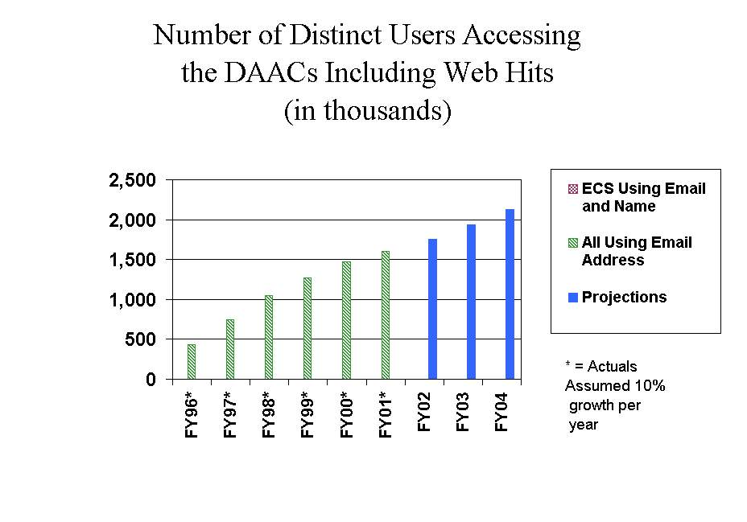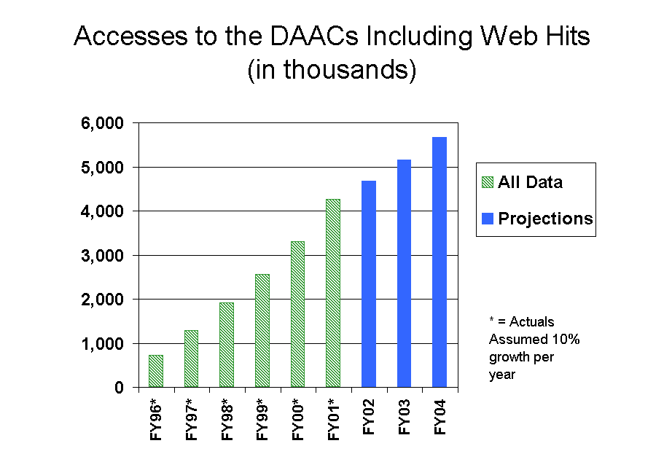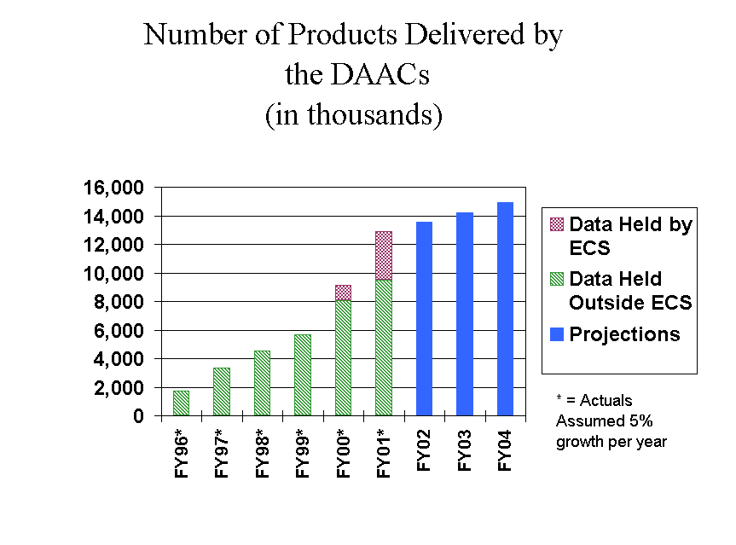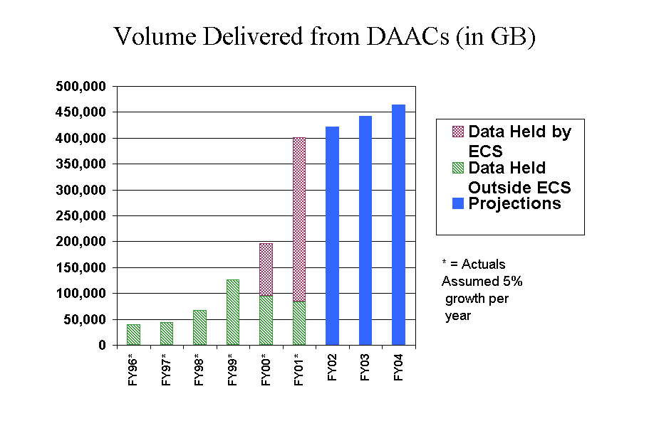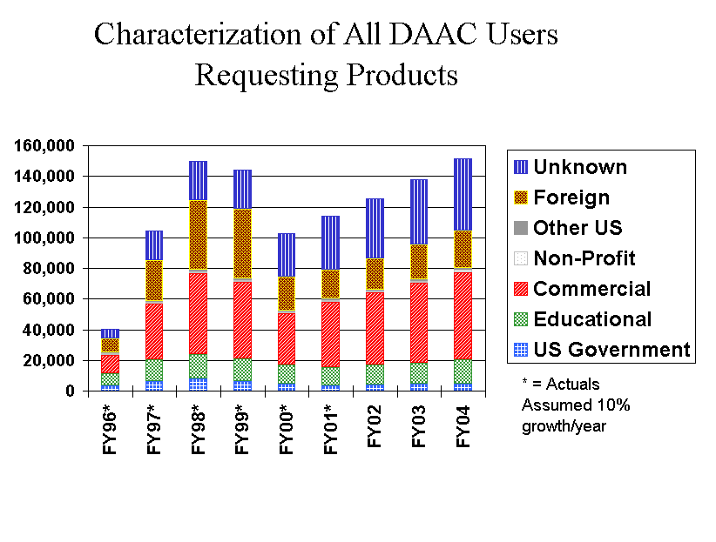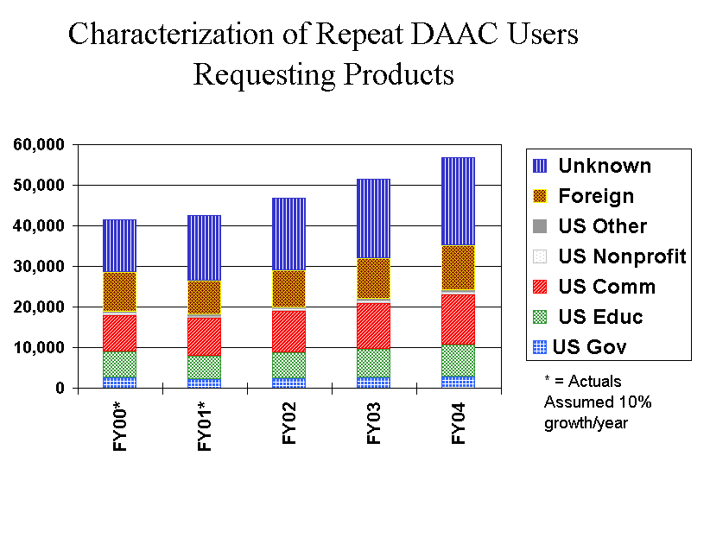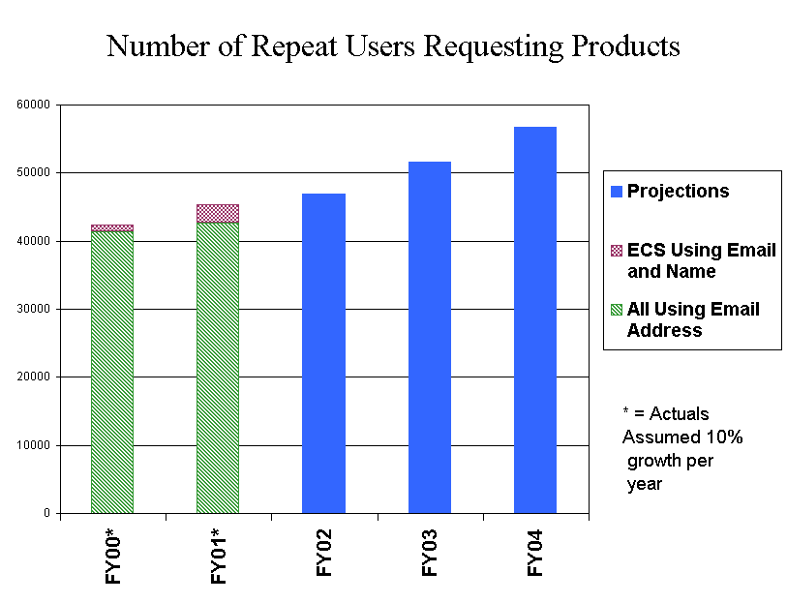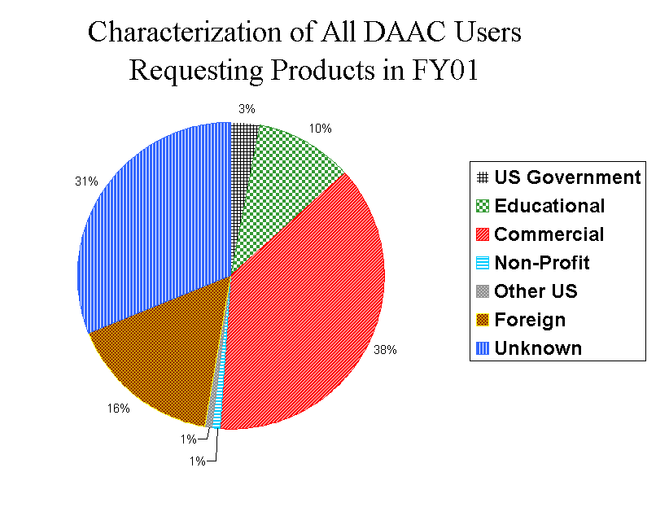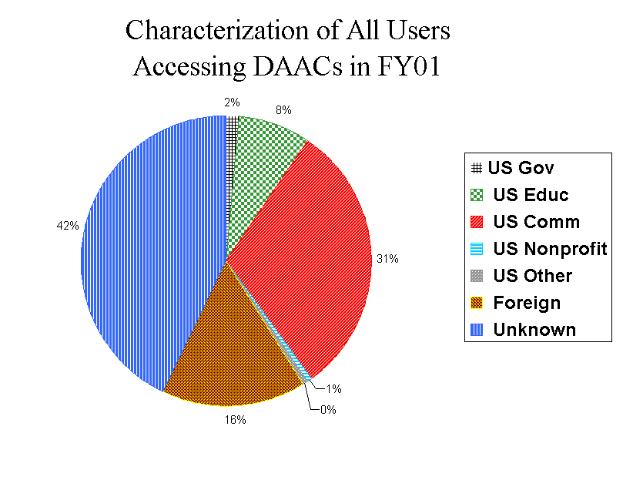
DAAC Fiscal Year 2001 Access Statistics for Non-ECS Data
Number of Distinct Users Accessing DAACs
TITLE | ASF | EDC | GHRC | GSFC | JPL | LARC | NSIDC | ORNL | SEDAC |  | TOTAL
EDG (users) |  |  |  |  |  |  |  |  |  |  | 33,950
Local IMS (users) | 0 | 0 | 4,679 | 0 | 0 | 0 | 0 | 0 | 0 |  | 4,679
WWW (users) | 34,217 | 117,206 | 122,663 | 284,642 | 121,572 | 80,335 | 188,367 | 105,932 | 483,555 |  | 1,538,489
FTP (users) | 186 | 3,895 | 334 | 2,121 | 1,735 | 0 | 683 | 276 | 1,492 |  | 10,722
Off-line (users) | 0 | 2,438 | 305 | 0 | 2,278 | 0 | 1,527 | 4,645 | 0 |  | 11,193
Total (users) | 34,403 | 123,539 | 127,981 | 286,763 | 125,585 | 80,335 | 190,577 | 110,853 | 485,047 |  | 1,599,033
Number of Accesses
TITLE | ASF | EDC | GHRC | GSFC | JPL | LARC | NSIDC | ORNL | SEDAC |  | TOTAL
EDG (accesses) |  |  |  |  |  |  |  |  |  |  | 880,363
Local IMS (accesses) | 0 | 0 | 5,798 | 0 | 0 | 0 | 0 | 0 | 0 |  | 5,798
WWW Inquiries | 59,623 | 179,855 | 344,716 | 594,158 | 289,818 | 140,397 | 360,954 | 206,004 | 997,861 |  | 3,173,386
WWW Data Retrievals | 0 | 28,061 | 0 | 79,308 | 0 | 0 | 0 | 1,497 | 18,819 |  | 127,685
FTP (accesses) | 759 | 11,499 | 12,176 | 11,230 | 10,818 | 0 | 4,123 | 1,367 | 5,903 |  | 57,875
Off-line (accesses) | 0 | 2,438 | 305 | 0 | 2,278 | 0 | 1,527 | 4,645 | 0 |  | 11,193
Total (accesses) | 60,382 | 221,853 | 362,995 | 684,696 | 302,914 | 140,397 | 366,604 | 213,513 | 1,022,583 |  | 4,256,300
REQUESTS AND RETRIEVALS
Product Request Tracking and Delivery
TITLE | ASF | EDC | GHRC | GSFC | JPL | LARC | NSIDC | ORNL | SEDAC |  | TOTAL
Subscriptions Pending | 0 | 0 | 0 | 0 | 0 | 0 | 0 | 0 | 0 |  | 0
New Subscriptions | 0 | 0 | 15,089 | 208 | 7,080 | 0 | 0 | 0 | 0 |  | 22,377
Products Requested | 21,216 | 2,219 | 1,342,917 | 3,725,260 | 28,597 | 222,728 | 2,040 | 605 | 0 |  | 5,345,582
TOTAL NEW | 21,216 | 2,219 | 1,358,006 | 3,725,468 | 35,677 | 222,728 | 2,040 | 605 | 0 |  | 5,367,959
Products Delivered | 16,225 | 2,163 | 753,057 | 2,762,623 | 35,717 | 216,892 | 1,950 | 542 | 0 |  | 3,789,169
Request Turnaround
Rejected by User | 0 | 25 | 0 | 0 | 350 | 0 | 0 | 0 | 0 |  | 375
Average (days) | 4 | 4 | 5 | 7 | 5 | 6 | 3 | 0 | 0 |  | 7
Maximum (days) | 618 | 82 | 40 | 254 | 368 | 96 | 97 | 0 | 0 |  | 618
Anonymous FTP and WWW Retrievals
FTP Product Retrievals | 5,282 | 194,755 | 941,911 | 1,223,649 | 2,105,217 | 0 | 202,484 | 25,500 | 195,795 |  | 4,894,593
WWW Product Retrievals | 0 | 310,013 | 0 | 444,571 | 0 | 0 | 0 | 7,996 | 61,377 |  | 823,957
TOTAL PRODUCTS DELIVERED | 21,507 | 506,931 | 1,694,968 | 4,430,843 | 2,140,934 | 216,892 | 204,434 | 34,038 | 257,172 |  | 9,507,719
System IMS Sessions Requesting Products
EDG |  |  |  |  |  |  |  |  |  |  | 11,088

Volume Delivered by DAACs (MB)
TITLE | ASF | EDC | GHRC | GSFC | JPL | LARC | NSIDC | ORNL | SEDAC |  | TOTAL
FTP (MB) | 519,171 | 977 | 1,206,441 | 8,887,846 | 0 | 3,486,127 | 0 | 0 | 0 |  | 14,100,562
Anon FTP (MB) | 10,439 | 1,235,080 | 998,481 | 9,091,064 | 2,861,443 | 0 | 165,984 | 21,634 | 120,747 |  | 14,504,872
WWW (MB) | 0 | 812,835 | 0 | 19,555 | 0 | 0 | 0 | 227 | 2,501 |  | 835,118
8mm (MB) | 248,879 | 169,830 | 3,252,219 | 14,044,722 | 9,874,599 | 92,887 | 0 | 0 | 0 |  | 27,683,136
4mm (MB) | 0 | 0 | 571,387 | 2,787,116 | 0 | 3,711 | 0 | 0 | 0 |  | 3,362,214
9 track (MB) | 0 | 0 | 0 | 0 | 0 | 0 | 0 | 0 | 0 |  | 0
DLT (MB) | 0 | 0 | 0 | 868,319 | 6,781,065 | 14,785 | 0 | 0 | 0 |  | 7,664,169
CD ROM (MB) | 0 | 796,680 | 22,296 | 492,415 | 15,336,015 | 0 | 0 | 639,533 | 0 |  | 17,286,939
CD Rec (MB) | 0 | 0 | 0 | 0 | 384,822 | 0 | 0 | 0 | 0 |  | 384,822
Floppy (MB) | 0 | 0 | 0 | 0 | 0 | 0 | 0 | 2 | 0 |  | 2
DVD (MB) | 0 | 0 | 0 | 0 | 26,894 | 0 | 0 | 0 | 0 |  | 26,894
Unknown (MB) | 1,493 | 488 | 231 | 0 | 0 | 0 | 0 | 0 | 0 |  | 2,212
Total Digital (MB) | 779,982 | 3,015,890 | 6,051,055 | 36,191,037 | 35,264,838 | 3,597,510 | 165,984 | 661,396 | 123,248 |  | 85,850,940

Deliveries by Types (Counts of Products)
TITLE | ASF | EDC | GHRC | GSFC | JPL | LARC | NSIDC | ORNL | SEDAC |  | TOTAL
FTP Retrievals (products) | 12,574 | 4 | 165,647 | 1,006,110 | 0 | 147,663 | 734 | 0 | 0 |  | 1,332,732
Anon FTP Retrievals (products) | 5,282 | 194,755 | 941,911 | 1,223,649 | 2,105,217 | 0 | 202,484 | 25,500 | 195,795 |  | 4,894,593
WWW Retrievals (products) | 0 | 310,013 | 0 | 444,571 | 0 | 0 | 0 | 7,996 | 61,377 |  | 823,957
8mm (products) | 3,635 | 599 | 480,809 | 1,321,107 | 4,256 | 66,746 | 8 | 0 | 0 |  | 1,877,160
4mm (products) | 0 | 0 | 93,098 | 415,931 | 0 | 19 | 0 | 0 | 0 |  | 509,048
9 track (products) | 0 | 0 | 0 | 0 | 0 | 0 | 0 | 0 | 0 |  | 0
DLT (products) | 0 | 0 | 0 | 16,146 | 244 | 2,464 | 0 | 0 | 0 |  | 18,854
CD ROM (products) | 0 | 1,558 | 2,088 | 286 | 30,614 | 0 | 548 | 403 | 0 |  | 35,497
CD Rec (products) | 0 | 0 | 0 | 0 | 601 | 0 | 1 | 0 | 0 |  | 602
Floppy (products) | 0 | 0 | 0 | 0 | 0 | 0 | 0 | 9 | 0 |  | 9
DVD (products) | 0 | 0 | 0 | 0 | 2 | 0 | 0 | 0 | 0 |  | 2
Unknown (products) | 16 | 2 | 11,415 | 13 | 0 | 0 | 413 | 130 | 0 |  | 11,989
Total Deliveries (products) | 21,507 | 506,931 | 1,694,968 | 4,427,813 | 2,140,934 | 216,892 | 204,188 | 34,038 | 257,172 |  | 9,504,443
Non-Digital Product Units Delivered by DAACs
TITLE | ASF | EDC | GHRC | GSFC | JPL | LARC | NSIDC | ORNL | SEDAC |  | TOTAL
Paper | 0 | 0 | 0 | 3,030 | 0 | 0 | 246 | 0 | 0 |  | 3,276
Film | 0 | 0 | 0 | 0 | 0 | 0 | 0 | 0 | 0 |  | 0
Video | 0 | 0 | 0 | 0 | 0 | 0 | 0 | 0 | 0 |  | 0

Volumes Delivered by Request Source (MB)
TITLE | ASF | EDC | GHRC | GSFC | JPL | LARC | NSIDC | ORNL | SEDAC |  | TOTAL
System IMS (MB) | 0 | 0 | 44,090 | 0 | 0 | 0 | 0 | 0 | 0 |  | 44,090
Local IMS (MB) | 0 | 0 | 2,862,838 | 0 | 0 | 0 | 0 | 0 | 0 |  | 2,862,838
DOTS (MB) | 769,542 | 967,974 | 0 | 27,080,418 | 0 | 0 | 0 | 0 | 0 |  | 28,817,934
E-mail (MB) | 0 | 0 | 1,712,273 | 0 | 14,062,162 | 0 | 0 | 0 | 0 |  | 15,774,435
FAX (MB) | 0 | 0 | 0 | 0 | 0 | 0 | 0 | 0 | 0 |  | 0
Phone (MB) | 0 | 0 | 9,072 | 0 | 779,113 | 0 | 0 | 0 | 0 |  | 788,185
Walk-in (MB) | 0 | 0 | 13,135 | 0 | 1,840,356 | 0 | 0 | 2,588 | 0 |  | 1,856,079
WWW.(MB) | 0 | 0 | 0 | 0 | 0 | 3,597,510 | 0 | 636,946 | 0 |  | 4,234,456
Mail (MB) | 0 | 0 | 0 | 0 | 1,019 | 0 | 0 | 0 | 0 |  | 1,019
Subscription (MB) | 0 | 0 | 411,166 | 0 | 15,720,746 | 0 | 0 | 0 | 0 |  | 16,131,912
Unknown.(MB) | 0 | 0 | 0 | 0 | 0 | 0 | 0 | 0 | 0 |  | 0
Anon FTP.(MB) | 10,439 | 1,235,080 | 998,481 | 9,091,064 | 2,861,443 | 0 | 165,984 | 21,634 | 120,747 |  | 14,504,872
WWW Retrievals (MB) | 0 | 812,835 | 0 | 19,555 | 0 | 0 | 0 | 227 | 2,501 |  | 835,118
Total Volume (MB) | 779,981 | 3,015,889 | 6,051,055 | 36,191,037 | 35,264,839 | 3,597,510 | 165,984 | 661,395 | 123,248 |  | 85,850,938

Deliveries by Request Source
TITLE | ASF | EDC | GHRC | GSFC | JPL | LARC | NSIDC | ORNL | SEDAC |  | TOTAL
System IMS (counts) | 0 | 0 | 3,940 | 0 | 0 | 0 | 0 | 0 | 0 |  | 3,940
Local IMS (counts) | 0 | 0 | 368,620 | 0 | 0 | 0 | 0 | 0 | 0 |  | 368,620
DOTS (counts) | 16,225 | 2,163 | 3,391 | 2,762,623 | 0 | 0 | 0 | 0 | 0 |  | 2,784,402
E-mail (counts) | 0 | 0 | 306,670 | 0 | 23,630 | 0 | 476 | 0 | 0 |  | 330,776
FAX (counts) | 0 | 0 | 0 | 0 | 0 | 0 | 0 | 0 | 0 |  | 0
Phone (counts) | 0 | 0 | 1,951 | 0 | 1,460 | 0 | 67 | 0 | 0 |  | 3,478
Walk-in (counts) | 0 | 0 | 1,612 | 0 | 3,364 | 0 | 1,394 | 1 | 0 |  | 6,371
WWW (counts) | 0 | 0 | 0 | 0 | 0 | 216,892 | 0 | 541 | 0 |  | 217,433
Mail (counts) | 0 | 0 | 0 | 0 | 2 | 0 | 13 | 0 | 0 |  | 15
Subscription (counts) | 0 | 0 | 66,873 | 0 | 7,261 | 0 | 0 | 0 | 0 |  | 74,134
Unknown.(counts) | 0 | 0 | 0 | 0 | 0 | 0 | 0 | 0 | 0 |  | 0
Anon FTP Retrievals.(counts) | 5,282 | 194,755 | 941,911 | 1,223,649 | 2,105,217 | 0 | 202,484 | 25,500 | 195,795 |  | 4,894,593
WWW Retrievals.(counts) | 0 | 310,013 | 0 | 444,571 | 0 | 0 | 0 | 7,996 | 61,377 |  | 823,957
Total Deliveries.(counts) | 21,507 | 506,931 | 1,694,968 | 4,430,843 | 2,140,934 | 216,892 | 204,434 | 34,038 | 257,172 |  | 9,507,719
NEW USERS REQUESTING AND RETRIEVING PRODUCTS
New Users Requesting Products Via IMS, Off-line, or WWW Order System, or Retrieving Via FTP
TITLE | ASF | EDC | GHRC | GSFC | JPL | LARC | NSIDC | ORNL | SEDAC | GCMD | TOTAL
US Government | 18 | 172 | 35 | 291 | 628 | 36 | 93 | 31 | 18 | 0 | 1,322
Educational | 47 | 314 | 108 | 463 | 1,146 | 63 | 246 | 118 | 169 | 0 | 2,674
Commercial | 21 | 998 | 91 | 431 | 14,150 | 38 | 198 | 107 | 425 | 0 | 16,459
Non-Profit | 4 | 96 | 6 | 35 | 300 | 5 | 28 | 9 | 48 | 0 | 531
Other USA | 1 | 48 | 5 | 39 | 110 | 1 | 12 | 5 | 23 | 0 | 244
Total USA | 91 | 1,628 | 245 | 1,259 | 16,334 | 143 | 577 | 270 | 683 | 0 | 21,230
Foreign | 44 | 1,356 | 106 | 942 | 930 | 86 | 312 | 177 | 335 | 0 | 4,288
Unknown | 28 | 377 | 21 | 108 | 214 | 1 | 44 | 13 | 138 | 0 | 944
Total | 163 | 3,361 | 372 | 2,309 | 17,478 | 230 | 933 | 460 | 1,156 | 0 | 26,462
New Users Retrieving Via WWW
TITLE | ASF | EDC | GHRC | GSFC | JPL | LARC | NSIDC | ORNL | SEDAC | GCMD | TOTAL
US Government | 0 | 1 | 0 | 616 | 0 | 0 | 0 | 9 | 99 | 0 | 725
Educational | 0 | 0 | 0 | 3,053 | 0 | 0 | 0 | 57 | 2,208 | 0 | 5,318
Commercial | 0 | 0 | 0 | 16,459 | 0 | 0 | 0 | 250 | 4,446 | 0 | 21,155
Non-Profit | 0 | 0 | 0 | 210 | 0 | 0 | 0 | 0 | 121 | 0 | 331
Other USA | 0 | 0 | 0 | 154 | 0 | 0 | 0 | 4 | 72 | 0 | 230
Total USA | 0 | 1 | 0 | 20,492 | 0 | 0 | 0 | 320 | 6,946 | 0 | 27,759
Foreign | 0 | 0 | 0 | 8,170 | 0 | 0 | 0 | 150 | 747 | 0 | 9,067
Unknown | 0 | 12,169 | 0 | 10,826 | 0 | 0 | 0 | 176 | 2,449 | 0 | 25,620
Total | 0 | 12,170 | 0 | 39,488 | 0 | 0 | 0 | 646 | 10,142 | 0 | 62,446
New Users Requesting or Retrieving Products - Union of Above
TITLE | ASF | EDC | GHRC | GSFC | JPL | LARC | NSIDC | ORNL | SEDAC | GCMD | TOTAL
US Government | 18 | 173 | 35 | 907 | 628 | 36 | 93 | 40 | 117 | 0 | 2,047
Educational | 47 | 314 | 108 | 3,516 | 1,146 | 63 | 246 | 175 | 2,377 | 0 | 7,992
Commercial | 21 | 998 | 91 | 16,890 | 14,150 | 38 | 198 | 357 | 4,871 | 0 | 37,614
Non-Profit | 4 | 96 | 6 | 245 | 300 | 5 | 28 | 9 | 169 | 0 | 862
Other USA | 1 | 48 | 5 | 193 | 110 | 1 | 12 | 9 | 95 | 0 | 474
Total USA | 91 | 1,629 | 245 | 21,751 | 16,334 | 143 | 577 | 590 | 7,629 | 0 | 48,989
Foreign | 44 | 1,356 | 106 | 9,112 | 930 | 86 | 312 | 327 | 1,082 | 0 | 13,355
Unknown | 28 | 12,546 | 21 | 10,934 | 214 | 1 | 44 | 189 | 2,587 | 0 | 26,564
Total | 163 | 15,531 | 372 | 41,797 | 17,478 | 230 | 933 | 1,106 | 11,298 | 0 | 88,908

ALL USERS REQUESTING AND RETRIEVING PRODUCTS
All Users Requesting Products Via IMS, Off-line, or WWW Order System, or Retrieving Via FTP
TITLE | ASF | EDC | GHRC | GSFC | JPL | LARC | NSIDC | ORNL | SEDAC | GCMD | TOTAL
US Government | 32 | 221 | 89 | 472 | 754 | 69 | 135 | 39 | 24 | 0 | 1,835
Educational | 82 | 424 | 148 | 684 | 1,271 | 105 | 403 | 148 | 209 | 0 | 3,474
Commercial | 45 | 1,210 | 122 | 561 | 14,273 | 48 | 246 | 135 | 536 | 0 | 17,176
Non-Profit | 4 | 119 | 8 | 56 | 315 | 5 | 34 | 13 | 68 | 0 | 622
Other USA | 2 | 59 | 5 | 44 | 115 | 4 | 15 | 5 | 29 | 0 | 278
Total USA | 165 | 2,033 | 372 | 1,817 | 16,728 | 231 | 833 | 340 | 866 | 0 | 23,385
Foreign | 70 | 1,716 | 162 | 1,334 | 1,133 | 121 | 428 | 231 | 433 | 0 | 5,628
Unknown | 57 | 511 | 56 | 197 | 300 | 1 | 84 | 49 | 193 | 0 | 1,448
Total | 292 | 4,260 | 590 | 3,348 | 18,161 | 353 | 1,345 | 620 | 1,492 | 0 | 30,461
All Users Retrieving Via WWW
TITLE | ASF | EDC | GHRC | GSFC | JPL | LARC | NSIDC | ORNL | SEDAC | GCMD | TOTAL
US Government | 0 | 1 | 0 | 1,465 | 0 | 0 | 0 | 37 | 190 | 0 | 1,693
Educational | 0 | 0 | 0 | 4,828 | 0 | 0 | 0 | 104 | 3,289 | 0 | 8,221
Commercial | 0 | 0 | 0 | 19,713 | 0 | 0 | 0 | 330 | 5,620 | 0 | 25,663
Non-Profit | 0 | 1 | 0 | 398 | 0 | 0 | 0 | 3 | 195 | 0 | 597
Other USA | 0 | 0 | 0 | 278 | 0 | 0 | 0 | 5 | 153 | 0 | 436
Total USA | 0 | 2 | 0 | 26,682 | 0 | 0 | 0 | 479 | 9,447 | 0 | 36,610
Foreign | 0 | 0 | 0 | 11,675 | 0 | 0 | 0 | 251 | 1,052 | 0 | 12,978
Unknown | 0 | 16,522 | 0 | 13,918 | 0 | 0 | 0 | 249 | 3,171 | 0 | 33,860
Total | 0 | 16,524 | 0 | 52,275 | 0 | 0 | 0 | 979 | 13,670 | 0 | 83,448

All Users Requesting or Retrieving Products - Union of Above
TITLE | ASF | EDC | GHRC | GSFC | JPL | LARC | NSIDC | ORNL | SEDAC | GCMD | TOTAL
US Government | 32 | 222 | 89 | 1,937 | 754 | 69 | 135 | 76 | 214 | 10,340 | 13,868
Educational | 82 | 424 | 148 | 5,512 | 1,271 | 105 | 403 | 252 | 3,498 | 15,642 | 27,337
Commercial | 45 | 1,210 | 122 | 20,274 | 14,273 | 48 | 246 | 465 | 6,156 | 86,721 | 129,560
Non-Profit | 4 | 120 | 8 | 454 | 315 | 5 | 34 | 16 | 263 | 1,978 | 3,197
Other USA | 2 | 59 | 5 | 322 | 115 | 4 | 15 | 10 | 182 | 0 | 714
Total USA | 165 | 2,035 | 372 | 28,499 | 16,728 | 231 | 833 | 819 | 10,313 | 114,681 | 174,676
Foreign | 70 | 1,716 | 162 | 13,009 | 1,133 | 121 | 428 | 482 | 1,485 | 50,309 | 68,915
Unknown | 57 | 17,033 | 56 | 14,115 | 300 | 1 | 84 | 298 | 3,364 | 57,098 | 92,406
Total | 292 | 20,784 | 590 | 55,623 | 18,161 | 353 | 1,345 | 1,599 | 15,162 | 222,088 | 335,997
REPEAT USERS REQUESTING AND RETRIEVING PRODUCTS
Repeat Users Requesting Products Via IMS, Off-line, or WWW Order System, or Retrieving Via FTP
TITLE | ASF | EDC | GHRC | GSFC | JPL | LARC | NSIDC | ORNL | SEDAC | GCMD | TOTAL
US Government | 22 | 108 | 68 | 296 | 208 | 51 | 69 | 10 | 11 | 0 | 843
Educational | 56 | 173 | 92 | 446 | 281 | 73 | 234 | 55 | 70 | 0 | 1,480
Commercial | 32 | 395 | 54 | 280 | 497 | 24 | 77 | 38 | 192 | 0 | 1,589
Non-Profit | 0 | 52 | 2 | 30 | 29 | 0 | 10 | 6 | 27 | 0 | 156
Other USA | 2 | 15 | 1 | 12 | 19 | 3 | 8 | 1 | 9 | 0 | 70
Total USA | 112 | 743 | 217 | 1,064 | 1,034 | 151 | 398 | 110 | 309 | 0 | 4,138
Foreign | 38 | 640 | 104 | 779 | 521 | 72 | 220 | 88 | 147 | 0 | 2,609
Unknown | 36 | 208 | 44 | 118 | 133 | 1 | 51 | 42 | 74 | 0 | 707
Total | 186 | 1,591 | 365 | 1,961 | 1,688 | 224 | 669 | 240 | 530 | 0 | 7,454

Repeat Users Retrieving Via WWW
TITLE | ASF | EDC | GHRC | GSFC | JPL | LARC | NSIDC | ORNL | SEDAC | GCMD | TOTAL
US Government | 0 | 0 | 0 | 1,118 | 0 | 0 | 0 | 36 | 136 | 0 | 1,290
Educational | 0 | 0 | 0 | 2,605 | 0 | 0 | 0 | 68 | 1,631 | 0 | 4,304
Commercial | 0 | 0 | 0 | 5,646 | 0 | 0 | 0 | 179 | 1,860 | 0 | 7,685
Non-Profit | 0 | 1 | 0 | 265 | 0 | 0 | 0 | 3 | 98 | 0 | 367
Other USA | 0 | 0 | 0 | 170 | 0 | 0 | 0 | 3 | 106 | 0 | 279
Total USA | 0 | 1 | 0 | 9,804 | 0 | 0 | 0 | 289 | 3,831 | 0 | 13,925
Foreign | 0 | 0 | 0 | 5,093 | 0 | 0 | 0 | 144 | 481 | 0 | 5,718
Unknown | 0 | 7,529 | 0 | 6,397 | 0 | 0 | 0 | 159 | 1,432 | 0 | 15,517
Total | 0 | 7,530 | 0 | 21,294 | 0 | 0 | 0 | 592 | 5,744 | 0 | 35,160
Repeat Users Requesting or Retrieving Products - Union of Above
TITLE | ASF | EDC | GHRC | GSFC | JPL | LARC | NSIDC | ORNL | SEDAC | GCMD | TOTAL
US Government | 22 | 108 | 68 | 1,414 | 208 | 51 | 69 | 46 | 147 | 0 | 2,133
Educational | 56 | 173 | 92 | 3,051 | 281 | 73 | 234 | 123 | 1,701 | 0 | 5,784
Commercial | 32 | 395 | 54 | 5,926 | 497 | 24 | 77 | 217 | 2,052 | 0 | 9,274
Non-Profit | 0 | 53 | 2 | 295 | 29 | 0 | 10 | 9 | 125 | 0 | 523
Other USA | 2 | 15 | 1 | 182 | 19 | 3 | 8 | 4 | 115 | 0 | 349
Total USA | 112 | 744 | 217 | 10,868 | 1,034 | 151 | 398 | 399 | 4,140 | 0 | 18,063
Foreign | 38 | 640 | 104 | 5,872 | 521 | 72 | 220 | 232 | 628 | 0 | 8,327
Unknown | 36 | 7,737 | 44 | 6,515 | 133 | 1 | 51 | 201 | 1,506 | 0 | 16,224
Total | 186 | 9,121 | 365 | 23,255 | 1,688 | 224 | 669 | 832 | 6,274 | 0 | 42,614
START | 10/01/2000
STOP | 09/30/2001

Total Number of Granules Ingested
ALL DAACs
2000-10-01 -- to -- 2001-09-30
Instrument | EDC | GSFC | LaRC | NSIDC | Totals
ACRIM |  |  | 1,974 |  | 1,974
AIRS |  | 1,210 |  |  | 1,210
AMSU |  | 35 |  |  | 35
ANCILLARY | 3,953 | 5,428 |  |  | 9,381
ASTER | 298,175 | 531 |  |  | 298,706
DAO |  | 8,735 | 749 |  | 9,484
FOS |  |  | 697 |  | 697
HSB |  | 126 |  |  | 126
LANDSAT-7 | 45,229 |  |  |  | 45,229
MISR |  |  | 51,029 |  | 51,029
MODIS | 915,024 | 1,289,241 | 402 | 333,412 | 2,538,079
MOPITT |  |  | 16,173 |  | 16,173
SAGE III |  |  | 208 |  | 208
SPACECRAFT |  | 19,909 | 10,264 |  | 30,173
SYSTEM | 57 | 117,054 | 3 | 1,158 | 118,272
Total | 1,262,438 | 1,442,269 | 81,499 | 334,570 | 3,120,776

Total Volume in MBytes Ingested
ALL DAACs
2000-10-01 -- to -- 2001-09-30
Instrument | EDC | GSFC | LaRC | NSIDC | Totals
ACRIM |  |  | 837 |  | 837
AIRS |  | 101,384 |  |  | 101,384
AMSU |  | 4 |  |  | 4
ANCILLARY | 134,033 | 86,282 |  |  | 220,316
ASTER | 31,696,746 | 44,305 |  |  | 31,741,051
DAO |  | 927,359 | 119,204 |  | 1,046,563
FOS |  |  | 665 |  | 665
HSB |  | 377 |  |  | 377
LANDSAT-7 | 47,291,170 |  |  |  | 47,291,170
MISR |  |  | 13,144,385 |  | 13,144,385
MODIS | 53,594,442 | 113,235,805 | 871 | 3,612,377 | 170,443,496
MOPITT |  |  | 189,885 |  | 189,885
SAGE III |  |  | 126 |  | 126
SPACECRAFT |  | 91,487 | 8,556 |  | 100,043
SYSTEM | 3 | 46,599 | 179 | 48 | 46,829
Total | 132,716,394 | 114,533,602 | 13,464,708 | 3,612,425 | 264,327,128

Total Number of Granules Archived
ALL DAACs
2000-10-01 -- to -- 2001-09-30
Instrument | EDC | GSFC | LaRC | NSIDC | Totals
ACRIM |  |  | 1,974 |  | 1,974
AIRS |  | 1,589 |  |  | 1,589
AMSU |  | 202 |  |  | 202
ANCILLARY | 4,213 | 15,461 | 4,504 |  | 24,178
ASTER | 473,980 | 531 | 4 |  | 474,515
DAO |  | 9,122 | 949 |  | 10,071
FOS |  |  | 700 |  | 700
HSB |  | 279 |  |  | 279
LANDSAT-7 | 262,464 |  |  |  | 262,464
MISR |  |  | 609,087 |  | 609,087
MODIS | 916,404 | 2,596,151 | 437 | 333,735 | 3,846,727
MOPITT |  |  | 16,216 |  | 16,216
SAGE III |  |  | 209 |  | 209
SPACECRAFT |  | 43,946 | 33,114 |  | 77,060
SYSTEM | 542 | 3,068 | 3,444 |  | 7,054
Total | 1,657,603 | 2,670,349 | 670,638 | 333,735 | 5,332,325

Total Volume in MBytes Retrieved from Archive
ALL DAACs
2000-10-01 -- to -- 2001-09-30
Instrument | EDC | GSFC | LaRC | NSIDC | Totals
ACRIM |  |  | 160 |  | 160
AIRS |  | 82,500 |  |  | 82,500
AMSU |  | 32 |  |  | 32
ANCILLARY | 75,250 | 637,998 | 7,558 |  | 720,807
ASTER | 14,065,744 | 77,315 | 5 |  | 14,143,064
DAO |  | 1,330,459 | 293,868 |  | 1,624,327
FOS |  |  | 647 |  | 647
HSB |  | 1,012 |  |  | 1,012
LANDSAT-7 | 6,532,362 |  |  |  | 6,532,362
MISR |  |  | 85,736,594 |  | 85,736,594
MODIS | 9,406,245 | 205,209,581 | 3 | 252,779 | 214,868,608
MOPITT |  |  | 192,065 |  | 192,065
MULTIPLE | 908 | 159,148 | 294,755 | 1,156 | 455,967
SAGE III |  |  | 192 |  | 192
SPACECRAFT |  | 75,669 | 27,693 |  | 103,362
SYSTEM | 1,659 | 80,510 | 257,515 | 1 | 339,685
Total | 30,082,168 | 207,654,224 | 86,811,055 | 253,935 | 324,801,382

Total Number of Granules Retrieved from Archive
ALL DAACs
2000-10-01 -- to -- 2001-09-30
Instrument | EDC | GSFC | LaRC | NSIDC | Totals
ACRIM |  |  | 672 |  | 672
AIRS |  | 1,027 |  |  | 1,027
AMSU |  | 27 |  |  | 27
ANCILLARY | 1,507 | 53,145 | 16,373 |  | 71,025
ASTER | 152,775 | 893 | 2 |  | 153,670
DAO |  | 15,472 | 1,836 |  | 17,308
FOS |  |  | 2,575 |  | 2,575
HSB |  | 148 |  |  | 148
LANDSAT-7 | 13,370 |  |  |  | 13,370
MISR |  |  | 872,519 |  | 872,519
MODIS | 114,376 | 1,845,208 | 6 | 21,579 | 1,981,169
MOPITT |  |  | 27,553 |  | 27,553
MULTIPLE | 9 | 36 | 2,525 | 2 | 2,572
SAGE III |  |  | 271 |  | 271
SPACECRAFT |  | 31,719 | 40,513 |  | 72,232
SYSTEM | 3,450 | 5,577 | 176,513 | 7 | 185,547
Total | 285,487 | 1,953,252 | 1,141,358 | 21,588 | 3,401,685

Total Number of Granules Processed

ALL DAACs
2000-10-01 -- to -- 2001-09-30
Instrument | EDC | GSFC | LaRC | NSIDC | Totals
AIRS |  | 2,780 |  |  | 2,780
AMSU |  | 459 |  |  | 459
ANCILLARY | 1,526 | 8,131 | 5,600 |  | 15,257
ASTER | 176,741 |  | 1 |  | 176,742
DAO |  | 986 |  |  | 986
FOS |  |  | 470 |  | 470
HSB |  | 381 |  |  | 381
MISR |  |  | 1,177,542 |  | 1,177,542
MODIS |  | 1,055,815 |  |  | 1,055,815
SPACECRAFT |  | 28,243 | 31,410 |  | 59,653
SYSTEM | 139,720 | 122,836 | 16,636 |  | 279,192
Total | 317,987 | 1,219,631 | 1,231,659 |  | 2,769,277

Total Volume in MBytes Archived
ALL DAACs
2000-10-01 -- to -- 2001-09-30
Instrument | EDC | GSFC | LaRC | NSIDC | Totals
ACRIM |  |  | 872 |  | 872
AIRS |  | 110,828 |  |  | 110,828
AMSU |  | 58 |  |  | 58
ANCILLARY | 172,492 | 379,449 | 2,030 |  | 553,971
ASTER | 38,184,057 | 46,457 |  |  | 38,230,514
DAO |  | 979,931 | 162,463 |  | 1,142,394
FOS |  |  | 174 |  | 174
HSB |  | 564 |  |  | 564
LANDSAT-7 | 49,906,776 |  |  |  | 49,906,776
MISR |  |  | 75,181,689 |  | 75,181,689
MODIS | 56,319,983 | 252,342,812 | 970 | 3,788,212 | 312,451,977
MOPITT |  |  | 199,557 |  | 199,557
SAGE III |  |  | 131 |  | 131
SPACECRAFT |  | 94,574 | 18,654 |  | 113,228
SYSTEM | 777 | 46,182 | 68,053 |  | 115,013
Total | 144,584,086 | 254,000,856 | 75,634,595 | 3,788,212 | 478,007,748

Distribution to Users

ALL DAACs
2000-10-01 -- to -- 2001-09-30
Metrics Provider | # Orders | # Requests | # Granules | # files | # Mbytes
EDC | 27,530 | 29,706 | 155,967 | 730,585 | 16,481,059
GSFC | 14,028 | 16,506 | 128,418 | 367,649 | 15,043,897
LaRC | 20,932 | 20,959 | 135,507 | 1,031,727 | 15,332,991
NSIDC | 473 | 473 | 20,877 | 44,319 | 251,766
Total | 62,963 | 67,644 | 440,769 | 2,174,280 | 47,109,713

